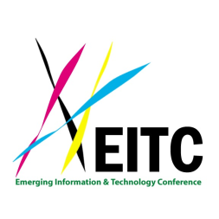 | International Conference on New Materials, Nanotechnology and  New Green Energy 2014  (EITA-New Materials 2014) or (EITA-EITC 2014)  Registration Form  "Recent Research Advances in New Materials, Nanotechnology  and New Green Energy"  The Y. S. Sun Green Building Research Center  National Cheng Kung University  Tainan, Republic of China (Taiwan)  Saturday-Sunday, November 22-23, 2014

Last Name First Name Middle Initial Chinese Name (if available)

Address (Number, Street, City, State, Zip Code, Country)

Affiliation Tel (Work) Tel (Home)

E-mail

Registration:

The EITA-New Materials 2014 (or the EITA-EITC 2014) is a free event, no charge. Please send your registration form to: eita.world@gmail.com (The deadline is November 20, 2014).

Please click the following link for complete details on the conference: the EITA-New Materials 2014 (http://tinyurl.com/EITA-NewMaterials2014).

Conference Venue:

The EITA-New Materials 2014 (or the EITA-EITC 2014) will be held at the Yun-Suan Sun Green Building Research Center, National Cheng Kung University (成功大學力行校區孫運璿綠建築研究大樓).

Please click the following link for general inquires or information on our organization: the EITA.

