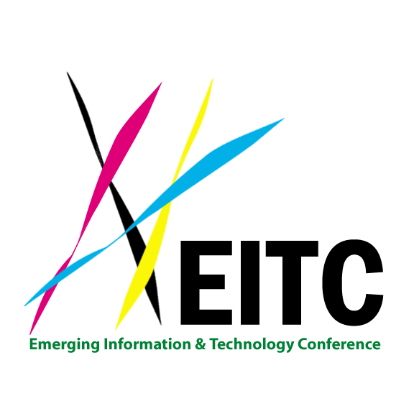

INVITATION

Dear Friends:

We are pleased to invite you and your colleagues to the “International Conference on New Materials, Nanotechnology and New Green Energy 2014 (the EITA-New Materials 2014) or (the EITA-EITC 2014)” (http://tinyurl.com/EITA-NewMaterials2014). The EITA-New Materials 2014, a free event (no charge), will be held on Saturday-Sunday, November 22-23, 2014 at the Yun-Suan Sun Green Building Research Center, National Cheng Kung University, Tainan, R.O.C. (Taiwan) (成功大學孫運璿綠建築研究大樓).
The theme of the EITA-New Materials 2014 is “Recent Research Advances in New Materials, Nanotechnology and New Green Energy“. We have invited more than 90 distinguished speakers to give talks at the Conference. Speakers will speak on the following topics:

- Workshop 1 (W1): Bio-Materials, Bio-SoC, Bio-Nanotech, Bio-NEMS/Bio-MEMS, and Water Purification Technology
- Workshop 2 (W2): Electronic, Photonic, and Magnetic Materials, Organic Polymer and Soft Materials
- Workshop 3 (W3): New Green Energy Materials, Ceramic Materials, Metallurgy and Materials
- Workshop 4 (W4): Smart Grid Technologies and Network Communications, New Green Energy Technologies and Green Buildings

Join us at the two-day Conference with your peers in business and R&D community to learn, share and connect. We look forward to meeting you on Saturday-Sunday, November 22-23, 2014 at the EITA-New Materials 2014 (or the EITA-EITC 2014).

Please click the following link to register: Start Registration.

Sincerely yours,

Organizing Committee
EITA-New Materials 2014
Web: http://www.eitc.org

